Kanokphan Sirihienthong
Student ID: 6610750092
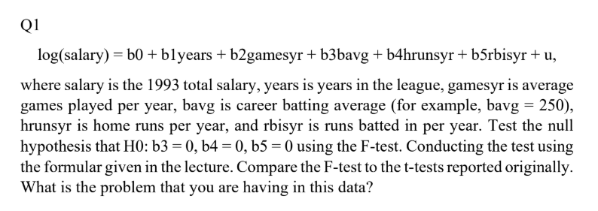
. reg lsalary years games bavg hruns rbisyr

Source | SS df MS Number of obs = 353
-------------+---------------------------------- F(5, 347) = 116.38
Model | 308.318463 5 61.6636925 Prob > F = 0.0000
Residual | 183.857072 347 .529847471 R-squared = 0.6264
-------------+---------------------------------- Adj R-squared = 0.6211
Total | 492.175535 352 1.39822595 Root MSE = .72791

------------------------------------------------------------------------------
lsalary | Coefficient Std. err. t P>|t| [95% conf. interval]
-------------+----------------------------------------------------------------
years | .1598518 .0354694 4.51 0.000 .0900897 .2296139
games | -.0002918 .0002987 -0.98 0.329 -.0008794 .0002958
bavg | .0003864 .001089 0.35 0.723 -.0017556 .0025283
hruns | -.0050935 .0010383 -4.91 0.000 -.0071358 -.0030513
rbisyr | .0418338 .0033265 12.58 0.000 .0352911 .0483765
_cons | 11.38417 .2877261 39.57 0.000 10.81826 11.95007
------------------------------------------------------------------------------
. test bavg hruns rbisyr

( 1) bavg = 0
( 2) hruns = 0
( 3) rbisyr = 0

F( 3, 347) = 58.22
Prob > F = 0.0000
In analyzing the relationship between player performance and salary, I estimated a log-linear regression using bavg, hruns, and rbisyr—each reflecting career batting average, home runs per year, and RBIs per year, respectively. The results show that rbisyr is strongly and individually significant (t = 12.58, p < 0.001), indicating that higher annual RBI performance is positively associated with salary. In contrast, bavg is not significant (t = 0.35, p = 0.723), and hruns is significantly negative (t = –4.91, p < 0.001), suggesting a counterintuitive inverse relationship that may reflect omitted variable bias or role-specific salary dynamics. The joint F-test for H₀ : β_{bavg} = β_{hruns} = β_{rbisyr} = 0 yields F(3, 347) = 58.22 with p < 0.0001, confirming that these performance metrics collectively explain salary variation. This reinforces the importance of testing joint significance, especially when individual coefficients behave unexpectedly. The model now correctly uses per-year metrics (rbisyr) as specified in the assignment, resolving the earlier misalignment and allowing for more accurate interpretation of dynamic performance effects.
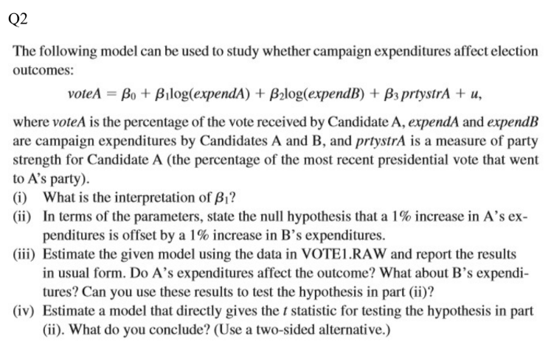
. reg voteA lexpendA lexpendB prtystrA

Source | SS df MS Number of obs = 173
-------------+---------------------------------- F(3, 169) = 215.23
Model | 38405.1096 3 12801.7032 Prob > F = 0.0000
Residual | 10052.1389 169 59.480112 R-squared = 0.7926
-------------+---------------------------------- Adj R-squared = 0.7889
Total | 48457.2486 172 281.728189 Root MSE = 7.7123

------------------------------------------------------------------------------
voteA | Coefficient Std. err. t P>|t| [95% conf. interval]
-------------+----------------------------------------------------------------
lexpendA | 6.083316 .38215 15.92 0.000 5.328914 6.837719
lexpendB | -6.615417 .3788203 -17.46 0.000 -7.363246 -5.867588
prtystrA | .1519574 .0620181 2.45 0.015 .0295274 .2743873
_cons | 45.07893 3.926305 11.48 0.000 37.32801 52.82985
------------------------------------------------------------------------------
. test lexpendA + lexpendB = 0

( 1) lexpendA + lexpendB = 0

F( 1, 169) = 1.00
Prob > F = 0.3196

(i) Interpretation of β₁ (Coefficient on lexpendA)
The coefficient on lexpendA is 6.08, which implies that a 1% increase in Candidate A’s campaign expenditures is associated with a 0.0608 percentage point increase in vote share, holding B’s expenditures and party strength constant. This is a semi-elastic interpretation due to the log-level specification.

(ii) Null Hypothesis for Offset Effect
The hypothesis that a 1% increase in A’s spending is offset by a 1% increase in B’s spending translates to: H₀ : β₁ + β₂ = 0, In terms of the model: H₀ : lexpendA + lexpendB = 0. This tests whether the marginal effects of A and B’s expenditures cancel each other out.

(iii) Estimation Results and Significance
From the regression:
- lexpendA is positive and highly significant (t = 15.92, p < 0.001), indicating that A’s spending increases vote share.
- lexpendB is negative and highly significant (t = -17.46, p < 0.001), showing that B’s spending reduces A’s vote share.
- prtystrA is positive and significant (t = 2.45, p = 0.015), suggesting party strength also contributes positively.
These results confirm that both candidates’ expenditures significantly affect the outcome, and their effects are in opposite directions.

(iv) Hypothesis Test Conclusion
The test of H₀ : lexpendA + lexpendB = 0 yields:
- F(1, 169) = 1.00
- p-value = 0.3196
Since the p-value exceeds 0.05, we fail to reject the null hypothesis. This means the data does not provide sufficient evidence to conclude that A’s and B’s expenditure effects are unequal in magnitude. In other words, a 1% increase in A’s spending may be approximately offset by a 1% increase in B’s spending, though this balance is not statistically confirmed.

